BINF 702 – Spring 2015 – Project - Final Report
Name – Sithalechumi Narayanan
Date – 4th May 2015
Email – snaray11@masonlive.gmu.edu
Work will be based on
Some Covariance Models for Longitudinal Count Data with Overdispersion.
Peter F. Thall and Stephen C. Vail (September 1990)

Abstract:

For longitudinal counts, a family of covariance models with predictive covariates is presented. Among repeated observations, the model accounts for overdispersion, heteroscedasticity and dependence. The approach is a quasi-likelihood regression similar to the formulation given by Liang and Zeger (Liang and Zeger, 1986). GEE – Generalised Estimating Equations for both the covariate parameters and the variance-covariance parameters are presented. Large-sample properties of the parameter estimates are derived. The proposed methods are illustrated by an analysis of epileptic seizure count data arising from a study of progabide as an adjuvant therapy for partial seizures. [1][2]

Background and Objectives:

We can deal with overdispersion by using a procedure known as quasi- likelihood regression, which allows the estimation of model parameters without fully knowing the error distribution of the response variable. In many respects it simply allows for the estimation of the value from the data rather than defining it to be unity for the binomial and Poisson distributions. A possible reason for overdispersion in this data is that they do not occur independently of one another. [5]

Quasi-Likelihood (QL) estimation is a technique which is used for estimating regression coefficients without fully specifying the distribution of the observed data. It provides a more flexible approach to estimation than Maximum Likelihood (ML) estimation. QL is one example of a more general method of estimation called estimating equations. The basis of the method of estimating equations is a set of simultaneous equations involving both the data and the unknown model parameters. These equations are then solved in order to obtain estimates of the parameters. There are two scenarios wherein QL estimation can be used. 1) To allow for over- or under-dispersion relative to the Poisson/ Binomial distribution – usually while maintaining the same linear predictor and link function chosen for the preliminary Poisson/ Binomial method. 2) To estimate regression coefficients when it’s not clear on how to specify the distribution of the observed data. By default, R uses Likelihood or Quasi-Likelihood method in estimating coefficients of count data given distribution (Poisson, Binomial or others). For the regression analysis of correlated observations, (Liang and Zeger, 1986) introduced GEE (Generalized Estimating Equations) approach. This approach generalized the estimation method of QL to correlated data.

R package ‘geepack’ for generalized estimating equations (GEE – Liang and Zeger, 1986). This method of GEE fits marginal mean models with the advantage that only correct specification of marginal means is needed for the parameter estimator to be consistent and asymptotically normal. This approach has become an important tool in analyzing longitudinal data or repeated measures arising in a wide variety of applications. Three features of geepack distinguish it from other implementations. 1) There is an interface function geeglm, which is designed to be as similar to glm as possible. 2) A jackknife variance estimator is available as an alternative to the sandwich estimator. 3) Covariates can be incorporated into the scale and correlation parameters in a similar fashion to the mean modeling. GEE is an approach that allows us to make valid inference by implicitly taken into account, the correlation. geeglm largely follows the syntax of the glm function and many of the methods available for glm objects are also available for geeglm objects. [3]

This paper is based on a randomized clinical trial that investigates the effect of an anti-epileptic drug Progabide. In this clinical trial, 59 patients who are epileptic were randomized to groups receiving either the anti-epileptic drug or a placebo in addition to standard chemotherapy. Epilepsy Data is a data frame of about 236 observations with 6 different variables such as Treatment (the treatment group, a factor with levels ‘placebo’ and ‘progabide’), Base (the number of seizures before the trial), Age (the patient’s age), Seizure.rate (the number of seizures – response variable), Period (treatment period, a factor ordered from 1 to 4) and Subject (the patient ID, a factor ordered from 1 to 59).
The numbers of seizures suffered in each of four, two-week periods were recorded for each patient along with a baseline seizure count for the eight weeks prior to being randomized to treatment and age. The primary goal of this data is to reinvestigate whether the numbers of epileptic seizures have been influenced by the use of this anti-epileptic drug when compared with a placebo.

Computational Methods:

When there is a single response for each subject, all generalized linear models (Nelder and Wedderburn, 1972; McCullagh and Nelder, 1983) are broadly applicable. However, data involving counts taken from biological units often exhibit variability exceeding than explained by exponential family probability models. In many circumstances, this can be modeled by unobserved random effects acting on the responses. The main problem faced by the scientist in such settings is identification of linear predictor in the model. Several authors have stressed the importance of accounting for overdispersion and heteroscedasticity in order to correctly test elements of the linear component. The quasi-likelihood approach to this problem was first introduced by Wedderburn, 1974. By circumstances wherein the nature and degree of the variability of the phenomenon over time may be as important as its average behavior. To account for regression on both time and the covariates, we denote by a vector Z, consisting of X and possibly some functions of time, with link function g connecting each mean μ to the parameter vector β.

An asymptotic distribution theory for the estimators then allows formal testing and subsequent remodeling of both mean μ and variance V, as functions of vector α and equation β. This formulation is analogous to that of Prentice, (Prentice, 1988) who provides a quasi-likelihood framework for correlated binary responses with covariates. He derives the joint distribution of the regression and covariance parameters under a generalized estimating equation formulation that models both the pairwise correlations ρ (Z) and the marginal probabilities π (Z) as functions of the covariates, where Z is the vector. [4]

In the R package ‘aer’ there is a function called dispersion test, which implements a test for overdispersion (Cameron & Trivedi, 1990). It follows a simple idea: In a Poisson model, the mean is E(Y) = μ and the variance is Var(Y) = μ as well. They are equal. The test simply tests this assumption as a null hypothesis against an alternative where Var(Y) = μ + c ∗ f (μ) where the constant c < 0 means underdispersion and c > 0 means overdispersion. The function f (.) is a function (often linear or quadratic; the former is the default). The resulting test is equivalent to testing H0:c=0 vs. H1:c≠0 and the test statistic used is a t statistic which is asymptotically standard normal under the null.

Covariance matrix

Consider the case of counts exhibiting extra-Poisson variation, in that σ > μ. This maybe checked empirically by comparing the sample mean and variance for each t. We derive an initial form for V under the following assumptions. Let γ be independent and identically distributed subject effects and ζ independent time effects, all unobserved and positive-valued. The two sets of effects are mutually independent. Conditional on these random effects, the responses are independent within subject.

There are three major simplifications and variants of this formulation. There are no time effects in V, and then it takes the form suggested by Nelder (Nelder, 1985) for repeated measurements. When there are no subject effects and we obtain the case of within-subject response independence with heteroscedastic overdispersion across time. Applying both constraints, α yields the univariate additive overdispersion model of Breslow. (Breslow, 1984) The heuristic derivation of V given above could be carried out equivalently by assuming a priori that all the random effects have mean 1, since E^2 (γ) and E^2(ζ) are absorbed into their respective variances. This corresponds to the usual linear model having within and between-subject variance components, but allowing heteroscedasticity over time. Thus, the two developments both can be carried out either from the full (Poisson or Gaussian) distributional assumption, or via quasi-likelihood with respective variance functions μ or 1. The variance matrix V does not vary with μ, however, while the analogous expression derived under the Poisson assumption is an explicit function of μ.

Estimation

In practice, the equations are solved via a two-operation procedure that is iterated, as in the following research work. (Green, 1984) (Liang and Zeger, 1986) (Nelder and Pregibon, 1987) and (Prentice, 1988) First U = 0, is solved for β using a modified Fisher scoring approach; then α is obtained by solving the moment equations U = 0. The moment equations are solved directly when possible, otherwise via Newton - Raphson. These two operations are applied alternately until θ converges. Initially V is set equal to the naïve diagonal matrix of usual variances, assuming independence within and between subjects. That is, estimation of α is suppressed. The estimates of β so obtained are those of a generalized linear model. The illustrative example thus may be interpreted only ordinarily, in that a larger value corresponds to a higher value of ρ^2, hence a better fit to the data. A generalized Pearson statistic would be rather misleading here due to the essential role of the moment equations in estimating V.

This result provides a joint asymptotic distribution for α and β. In this sense it maybe regarded as an extension of Theorem 2 (Liang and Zeger, 1986), with the important difference that we assume V is correct while they do not. From another viewpoint, our results are a multivariate version of those given by (Moore, 1986). (Prentice, 1988) provides a similar distribution theory for the case of binary responses, but estimates the second moment parameters in a different manner. The general expression for V suggests the alternative q = (n+1) – parameter model so that overdispersion is represented both additively and multiplicatively. This form of the variance is suggested in unpublished work by Nelder for the univariate case (n = 1), where he notes that it was used by Bartlett as early as 1936 to model insect count data. The requirement that all σ > 0, maybe relaxed by setting it to a suitable form of σ^2 and correlation ρ.

This is essentially the correlation formulation proposed by (Liang and Zeger, 1986), but with time-varying overdispersion. Zeger (1988) also presents a regression model for a time series of counts with similar correlation structure. This formulation may be more desirable in settings where correlations that vary with (t, u) are appropriate, since the assumption that the ζ’s are independent does not provide such structure.

The various forms of V are presented systematically in Table 1 (See Appendix B – Tables).
Table 1 – Formulations for the within-subject covariance matrix V, suppressing the subject index I for simplicity. Each cell contains the variance σ^2 and covariance σ of the model. The first two entries in column 2 of the table are the most general models with columns 1 and 3 containing their respective independence and correlation versions. For convenience, we shall refer to each model by its two-digit row-column location in the table.
Table 2 (See Appendix B – Tables). Successive two-week seizure counts for 59 epileptics. Covariates are adjuvant treatment (0 = placebo, 1 = progabide), eight-week baseline seizure counts and age (in years). A part of the table is shown.

In particular, 31 is the usual multiplicative overdispersion model while 41 is the additive overdispersion model treated by (Williams, 1982), (Breslow, 1984), (Moore, 1986) and (Lawless, 1987). The fifth row is obtained from row 1 by setting α = 1, (1 <= t <= n), so that 52 is Nelder’s proposal. (Nelder, 1985) while 51 is the usual generalized linear model. Patients suffering from simple and complex partial seizures were randomized to receive either the antiepileptic drug progabide or a placebo, as an adjuvant to standard chemotherapy. At each of four successive post-randomization clinic visits, the number of seizures occurring over the previous two weeks was reported. As shown in Table – 3, the seizure counts exhibit a high degree of extra-Poisson variation, heteroscedasticity and within-patient dependence.
Table 3 (See Appendix B – Tables) Summary statistics for the two-week seizure counts. Within each group, the first column contains the mean and variance at each visit, followed by the correlations.
For these data, the original model 22 that was derived heuristically gives the best fit, although model 12 and the correlation model 23 fit the data almost well. The common properties of these three models are that, in addition to their accounting for the rather strong within-subject covariance, the time-varying overdispersion is parameterized additively in their variances. A visual scan of the data suggests that progabide patient #207 is an outlier, since both the baseline and post-treatment counts are much higher than those of the other patients. Figure 1 & 2 (See Appendix C – Figures) Hongfei Guo – Epileptic Seizures Data Analysis. These two figures are a proof to say that the patient with patient ID # 207 has higher number of seizure counts when compared with the others and it is highlighted with a red rectangle.

Deletion of this patient produces a marked drop in the means, variances and correlations within the progabide group. While a comparison of these adjusted summary statistics with those of the placebo group suggests a greater treatment effect, deletion of this patient from the data has no clinical basis. This phenomenon will arise almost invariably in any setting where a predictive model is fit to longitudinal data. The model thus accounts for the high dispersion in these data quite well, since none of the extreme residuals was due to a value of the response variable being large relative to the sample.

Results and Discussion:

Quasi-likelihood regression models for the longitudinal data recently have received considerable attention in the literature. As an alternative to the generalized quasi-likelihood approach where V is modeled parametrically, (Wei and Stram, 1988) propose modeling only the marginal distributions while estimating the within-subject covariance empirically. Other treatments are given by (McCullagh, 1983), (Jorgensen, 1983, 1987), (Green, 1984) and (Godambe and Heyde, 1987). (Davidian and Carroll, 1987) treat the heterogeneous regression model, they also focus on the variance function, proposing that α be estimated by maximizing the so-called “pseudo-likelihood” obtained by conditioning on β and assuming a Gaussian form. For application of this approach to estimation of α in the generalized estimating equation regime of (Liang and Zeger, 1986), with A the diagonal matrix of usual generalized linear model variances, the same sort of consideration would apply – namely, the determinant and inverse of the “working correlation matrix” R (α) should be computable in closed form. Prentice (Prentice, 1988) estimates covariance matrix parameters in the case of correlated binary responses via a second set of generalized estimating equations, solved along with those for β.

Conclusion:

The primary aim of the present article has been to propose a family of parametric models for the covariance matrix in the quasi-likelihood regression framework for longitudinal count data. As the above generalization shows, more complex versions of the models used here to fit the epilepsy data certainly are available, and quite possibly may give better fits. The data analysis is intended to provide a reasonably simple illustration of the general methodology, however, so that we have intentionally avoided using more elaborate versions of V. Still, the models presented in Table 1, comprise a broad collection of within-subject covariance structures, while each parameterization of V is rather parsimonious. Given the distributional results for both α and β, this provides a practical means for modeling both μ and V in the generalized estimating equation setting.

Final brief description:

The interaction between treatment and baseline seizure rate in this analysis produces a rather interesting result – namely, the predicted mean seizure rate for the progabide group is either higher or lower than that for the placebo group, accordingly as the baseline count does or does not exceed a critical threshold. This threshold varies between 11.2 and 15.2 seizures per 2-week period for the seven models considered, with the highest value corresponding to model 22. This suggests that progabide may be contraindicated for patients with high seizure rates. We regard this as a qualitative result, however, since it is based on a single data set and a particular family of models.

References:

- Thall, P.F., and Vail, S.C. (1990). Some covariance models for longitudinal count data and overdispersion. Biometrics 46, 657-671.
- Liang, K.Y., and Zeger, S.L. (1986). Longitudinal data analysis using Generalised Linear Models. Biometrika 73, 13-22.
- Halekoh, U., Hojsgaard, S., and Yan, J. (2006). The R package geepack for Generalized Estimating Equations. Journal of Statistics Software 15, 1-11.
- Prentice, R.L. (1988). Correlated binary regression with covariates specific to each binary observation. Biometrics 44, 1033-1048.
- Everitt, B.S., and Hothorn, T. (2014). A Handbook of Statistical Analyses using R. (Florida: CRC Press).

Appendix:

A) R code and plots
> #BINF702 SPRING 2015 Project R Script
> #Name - Sithalechumi Narayanan
> #Date - May 4th 2015
> #Name of file - epilepsy_dataset.r

> #Based on "A handbook of Statistical Analyses Using R" - Chapter 6,
> #Chapter 11 and Chapter 13 - Brian S. Everitt and Torsten Hothorn
> #R Documentation
> data("epilepsy", package = "HSAUR")
> library(lattice)

> str(epilepsy)
'data.frame': 236 obs. of 6 variables:
$ treatment : Factor w/ 2 levels "placebo","Progabide": 1 1 1 1 1 1 1 1 1 1 ...
$ base : int 11 11 11 11 11 11 11 11 6 6 ...
$ age : int 31 31 31 31 30 30 30 30 25 25 ...
$ seizure.rate: int 5 3 3 3 3 5 3 3 2 4 ...
$ period : Ord.factor w/ 4 levels "1"<"2"<"3"<"4": 1 2 3 4 1 2 3 4 1 2 ...
$ subject : Factor w/ 59 levels "1","2","3","4",..: 1 1 1 1 2 2 2 2 3 3 ...

> dotplot(I(seizure.rate / base) ~ period | subject, data = epilepsy,
+ subset = treatment == "Progabide")

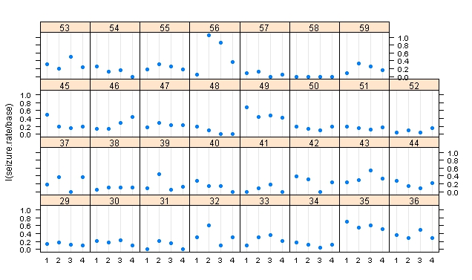

> #Finding mean and variance
> itp <- interaction(epilepsy$treatment, epilepsy$period)
> tapply(epilepsy$seizure.rate, itp, mean)
placebo.1 Progabide.1 placebo.2 Progabide.2 placebo.3 Progabide.3
9.357143 8.580645 8.285714 8.419355 8.785714 8.129032
placebo.4 Progabide.4
7.964286 6.709677

> tapply(epilepsy$seizure.rate, itp, var)
placebo.1 Progabide.1 placebo.2 Progabide.2 placebo.3 Progabide.3
102.75661 332.71828 66.65608 140.65161 215.28571 193.04946
placebo.4 Progabide.4
58.18386 126.87957

> install.packages("geepack")
trying URL 'http://cran.rstudio.com/bin/windows/contrib/3.1/geepack_1.2-0.zip'
Content type 'application/zip' length 931111 bytes (909 Kb)
opened URL
downloaded 909 Kb

package ‘geepack’ successfully unpacked and MD5 sums checked

The downloaded binary packages are in
C:\Documents and Settings\Vostro 1500\Local Settings\Temp\RtmpSW6ik9\downloaded_packages

> #Boxplot for Placebo and Progabide with the number of seizures
> layout(matrix(1:2, nrow = 1))
> ylim <- range(epilepsy$seizure.rate)
> placebo <- subset(epilepsy, treatment == "placebo")
> progabide <- subset(epilepsy, treatment == "Progabide")

> boxplot(seizure.rate ~ period, data = placebo,
+ ylab = "Number of seizures",
+ xlab = "Period", ylim = ylim, main = "Placebo")

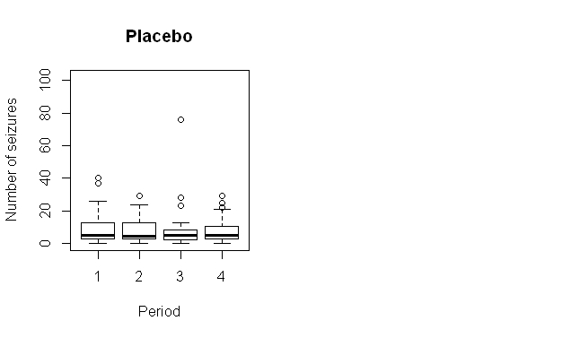

> boxplot(seizure.rate ~ period, data = progabide,
+ main = "Progabide", ylab = "Number of seizures",
+ xlab = "Period", ylim = ylim)

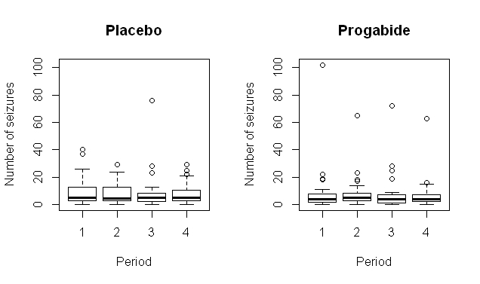

> library(gee)
> library(MASS)
> data(OME)
> per <- rep(log(2),nrow(epilepsy))
> epilepsy$period <- as.numeric(epilepsy$period)
> fm <- seizure.rate ~ base + age + treatment + offset(per)
> #To find Generalized Estimating Equation GEE

> epilepsy_gee1 <- gee(fm, data = epilepsy, family = "poisson",
+ id = subject, corstr = "independence", scale.fix = TRUE,
+ scale.value = 1)
Beginning Cgee S-function, @(#) geeformula.q 4.13 98/01/27
running glm to get initial regression estimate
(Intercept) base age
-0.13061561 0.02265174 0.02274013
treatmentProgabide
-0.15270095

> epilepsy_gee2 <- gee(fm, data = epilepsy, family = "poisson",
+ id = subject, corstr = "exchangeable", scale.fix = TRUE,
+ scale.value = 1)
Beginning Cgee S-function, @(#) geeformula.q 4.13 98/01/27
running glm to get initial regression estimate
(Intercept) base age
-0.13061561 0.02265174 0.02274013
treatmentProgabide
-0.15270095

> epilepsy_gee3 <- gee(fm, data = epilepsy, family = "poisson",
+ id = subject, corstr = "exchangeable", scale.fix = FALSE,
+ scale.value = 1)
Beginning Cgee S-function, @(#) geeformula.q 4.13 98/01/27
running glm to get initial regression estimate
(Intercept) base age
-0.13061561 0.02265174 0.02274013
treatmentProgabide
-0.15270095

> #Boxplot for Placebo and Progabide with Log number of seizures
> layout(matrix(1:2, nrow = 1))
> ylim <- range(log(epilepsy$seizure.rate + 1))

> boxplot(log(seizure.rate + 1) ~ period, data = placebo,
+ main = "Placebo", ylab = "Log number of seizures",
+ xlab = "Period", ylim = ylim)

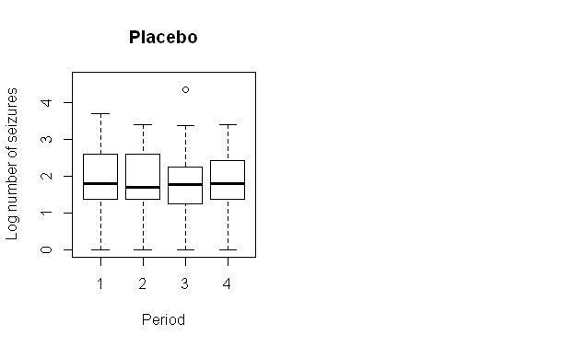

> boxplot(log(seizure.rate + 1) ~ period, data = progabide,
+ main = "Progabide", ylab = "Log number of seizures",
+ xlab = "Period", ylim = ylim)

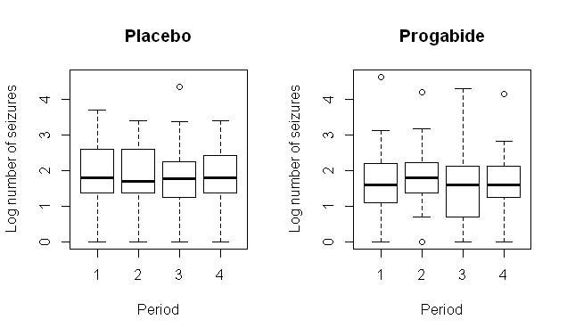

> #Summary details for all the estimate values

> summary(epilepsy_glm)

Call:
glm(formula = fm, family = "poisson", data = epilepsy)

Deviance Residuals:
Min 1Q Median 3Q Max
-4.4360 -1.4034 -0.5029 0.4842 12.3223

Coefficients:
Estimate Std. Error z value Pr(>|z|)
(Intercept) -0.1306156 0.1356191 -0.963 0.3355
base 0.0226517 0.0005093 44.476 < 2e-16 ***
age 0.0227401 0.0040240 5.651 1.59e-08 ***
treatmentProgabide -0.1527009 0.0478051 -3.194 0.0014 **
---
Signif. codes: 0 ‘***’ 0.001 ‘**’ 0.01 ‘*’ 0.05 ‘.’ 0.1 ‘ ’ 1

(Dispersion parameter for poisson family taken to be 1)

Null deviance: 2521.75 on 235 degrees of freedom
Residual deviance: 958.46 on 232 degrees of freedom
AIC: 1732.5

Number of Fisher Scoring iterations: 5

> summary(epilepsy_gee1)

GEE: GENERALIZED LINEAR MODELS FOR DEPENDENT DATA
gee S-function, version 4.13 modified 98/01/27 (1998)

Model:
Link: Logarithm
Variance to Mean Relation: Poisson
Correlation Structure: Independent

Call:
gee(formula = fm, id = subject, data = epilepsy, family = "poisson",
corstr = "independence", scale.fix = TRUE, scale.value = 1)

Summary of Residuals:
Min 1Q Median 3Q Max
-4.9195387 0.1808059 1.7073405 4.8850644 69.9658560

Coefficients:
Estimate Naive S.E. Naive z Robust S.E.
(Intercept) -0.13061561 0.1356191185 -0.9631062 0.365148155
base 0.02265174 0.0005093011 44.4761250 0.001235664
age 0.02274013 0.0040239970 5.6511312 0.011580405
treatmentProgabide -0.15270095 0.0478051054 -3.1942393 0.171108915
Robust z
(Intercept) -0.3577058
base 18.3316325
age 1.9636736
treatmentProgabide -0.8924196

Estimated Scale Parameter: 1
Number of Iterations: 1

Working Correlation
[,1] [,2] [,3] [,4]
[1,] 1 0 0 0
[2,] 0 1 0 0
[3,] 0 0 1 0
[4,] 0 0 0 1

> summary(epilepsy_gee2)

GEE: GENERALIZED LINEAR MODELS FOR DEPENDENT DATA
gee S-function, version 4.13 modified 98/01/27 (1998)

Model:
Link: Logarithm
Variance to Mean Relation: Poisson
Correlation Structure: Exchangeable

Call:
gee(formula = fm, id = subject, data = epilepsy, family = "poisson",
corstr = "exchangeable", scale.fix = TRUE, scale.value = 1)

Summary of Residuals:
Min 1Q Median 3Q Max
-4.9195387 0.1808059 1.7073405 4.8850644 69.9658560

Coefficients:
Estimate Naive S.E. Naive z Robust S.E.
(Intercept) -0.13061561 0.2004416507 -0.6516391 0.365148155
base 0.02265174 0.0007527342 30.0926122 0.001235664
age 0.02274013 0.0059473665 3.8235638 0.011580405
treatmentProgabide -0.15270095 0.0706547450 -2.1612270 0.171108915
Robust z
(Intercept) -0.3577058
base 18.3316325
age 1.9636736
treatmentProgabide -0.8924196

Estimated Scale Parameter: 1
Number of Iterations: 1

Working Correlation
[,1] [,2] [,3] [,4]
[1,] 1.0000000 0.3948033 0.3948033 0.3948033
[2,] 0.3948033 1.0000000 0.3948033 0.3948033
[3,] 0.3948033 0.3948033 1.0000000 0.3948033
[4,] 0.3948033 0.3948033 0.3948033 1.0000000

> summary(epilepsy_gee3)

GEE: GENERALIZED LINEAR MODELS FOR DEPENDENT DATA
gee S-function, version 4.13 modified 98/01/27 (1998)

Model:
Link: Logarithm
Variance to Mean Relation: Poisson
Correlation Structure: Exchangeable

Call:
gee(formula = fm, id = subject, data = epilepsy, family = "poisson",
corstr = "exchangeable", scale.fix = FALSE, scale.value = 1)

Summary of Residuals:
Min 1Q Median 3Q Max
-4.9195387 0.1808059 1.7073405 4.8850644 69.9658560

Coefficients:
Estimate Naive S.E. Naive z Robust S.E.
(Intercept) -0.13061561 0.45219954 -0.2888451 0.365148155
base 0.02265174 0.00169818 13.3388301 0.001235664
age 0.02274013 0.01341735 1.6948302 0.011580405
treatmentProgabide -0.15270095 0.15939823 -0.9579840 0.171108915
Robust z
(Intercept) -0.3577058
base 18.3316325
age 1.9636736
treatmentProgabide -0.8924196

Estimated Scale Parameter: 5.089608
Number of Iterations: 1

Working Correlation
[,1] [,2] [,3] [,4]
[1,] 1.0000000 0.3948033 0.3948033 0.3948033
[2,] 0.3948033 1.0000000 0.3948033 0.3948033
[3,] 0.3948033 0.3948033 1.0000000 0.3948033
[4,] 0.3948033 0.3948033 0.3948033 1.0000000

Appendix B) Tables – (Thall and Vail, 1990)
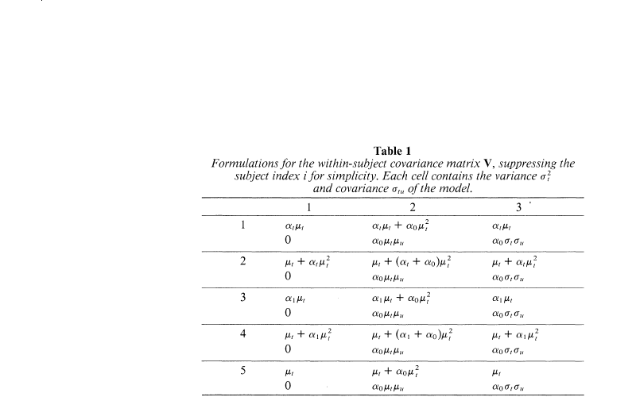

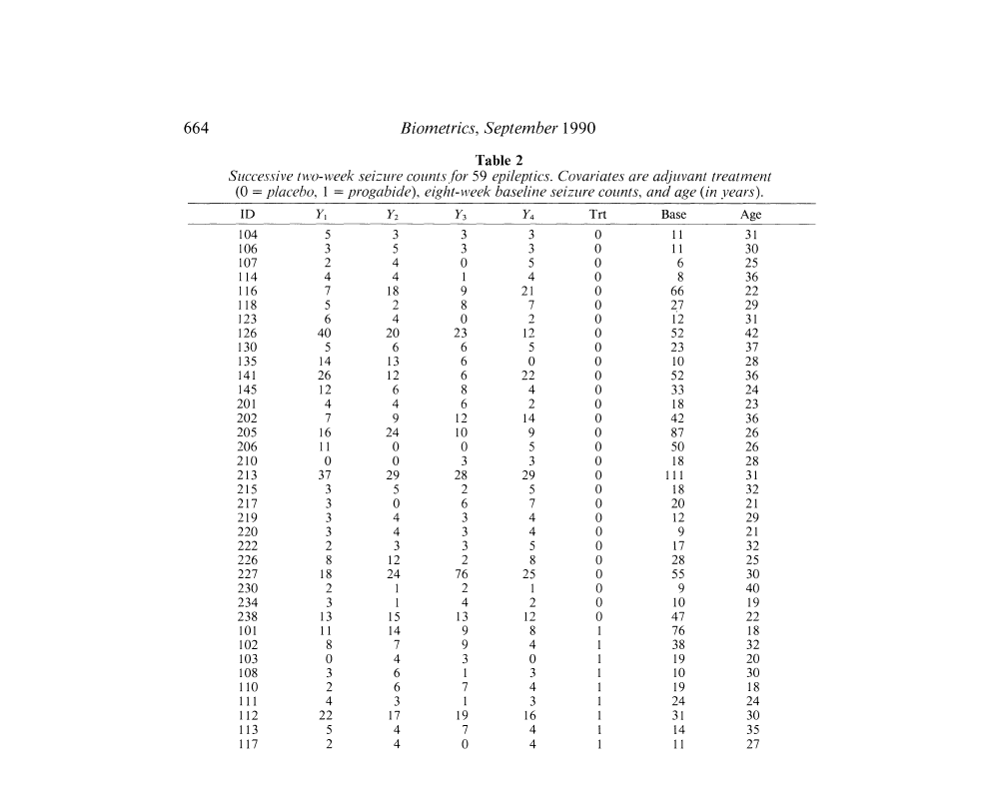

Table - 3
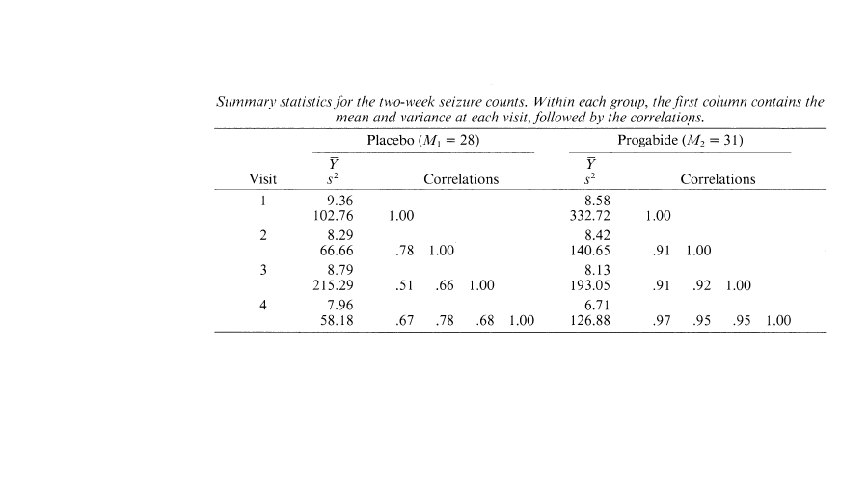

Appendix C) Figures – (Hongfei Guo – Epileptic Seizures Data Analysis)
Figure - 1
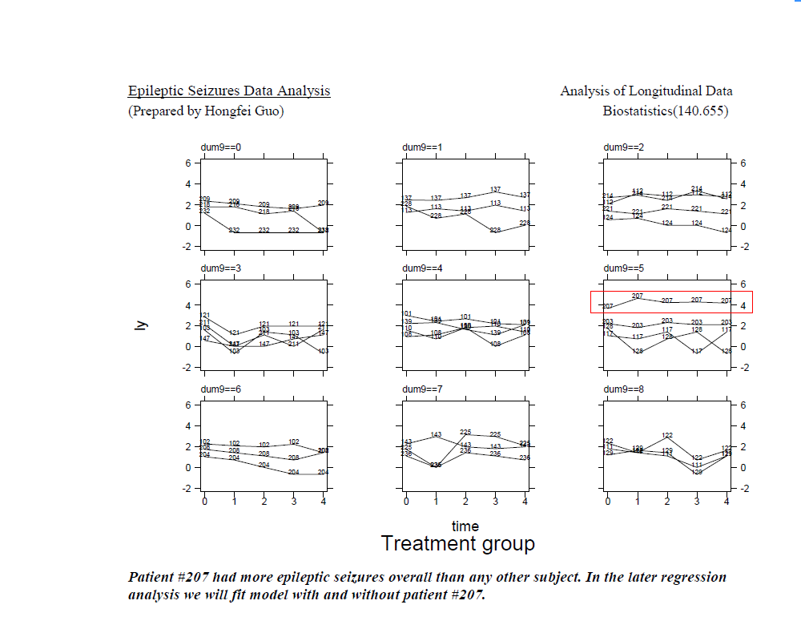

Figure - 2
